VM Metadata

1. Crate VM (follow same steps as shown is Lab-1 only below changes)
2. Change boot disk type to Standard persistent disk

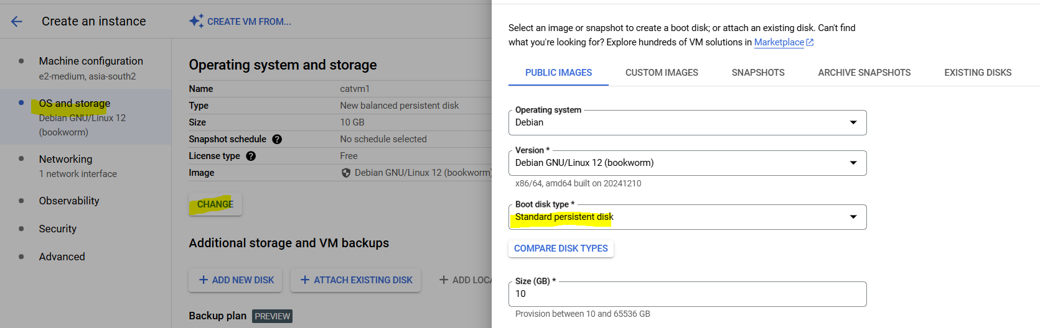

1. Allow http and https traffic

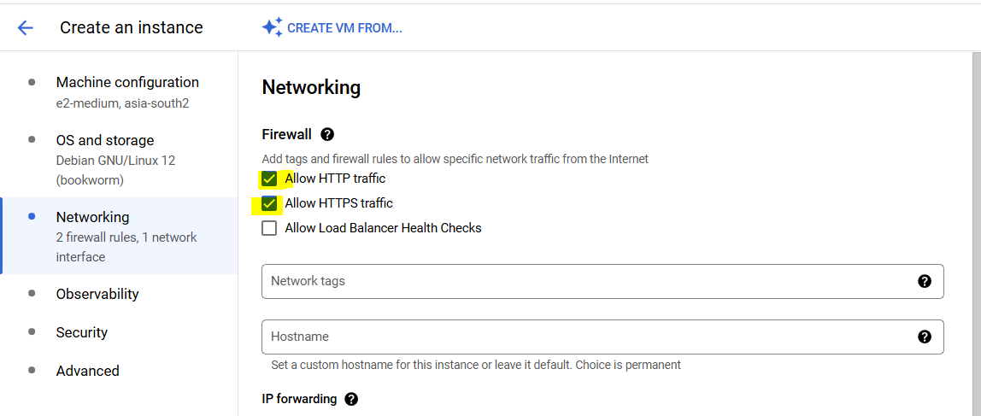

1. In Advanced, add message “Hosts catalogue part of Readit system” to description

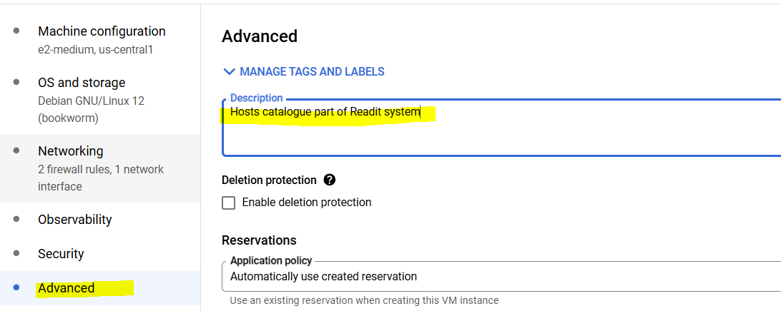

1. Create the VM
2. Login to VM
3. Run below command

curl "http://metadata.google.internal/computeMetadata/v1/" -H "Metadata-Flavor: Google"

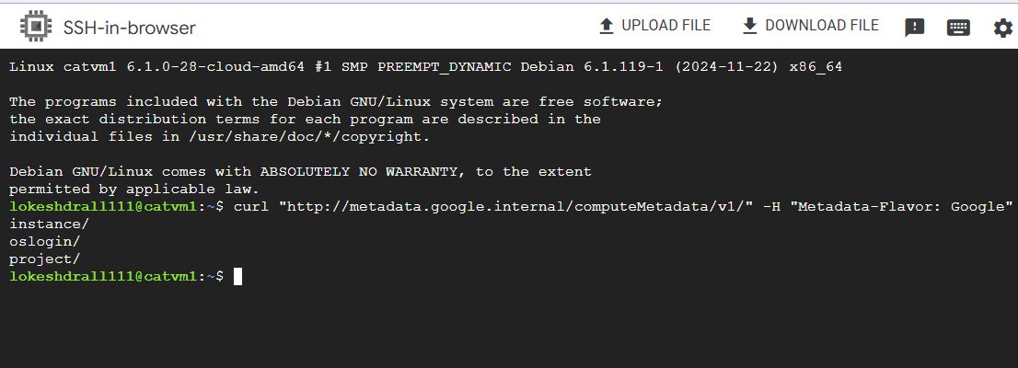

It will show directories of metadata, as metadata is stored in multiple directories

1. Now, to see data within any directory add name of that directory in previous command like below

curl "http://metadata.google.internal/computeMetadata/v1/instance/" -H "Metadata-Flavor: Google"

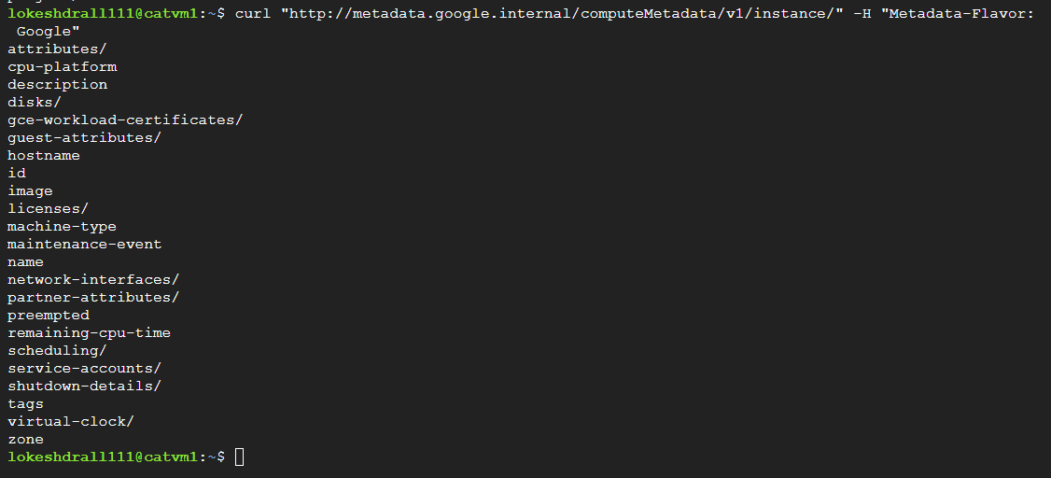

1. Now instead of going through all directories within this folder, we can also get all data collectively, for this run below command

curl "http://metadata.google.internal/computeMetadata/v1/instance/?recursive=true" -H "Metadata-Flavor: Google"

This will give data like below, but it is not easy to read.

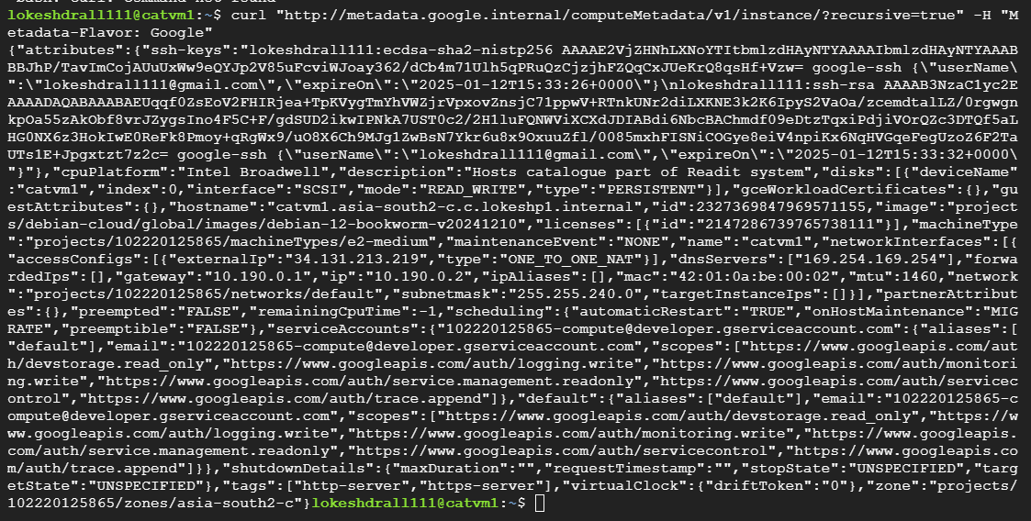

1. To make it read easy, copy starting from bracket to end of bracket
2. Open VS code
3. File>New Text File
4. Paste the data there

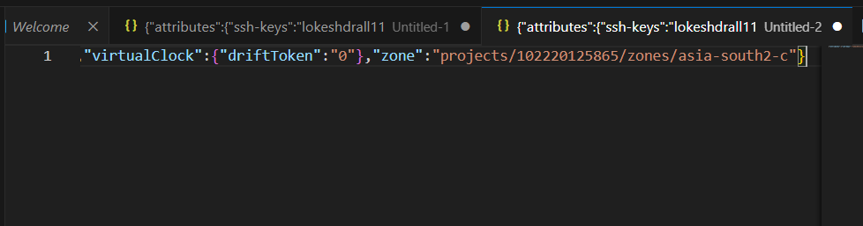

1. But data is still not formatted, so to format it press alt+shift+f
2. Now can see data like below

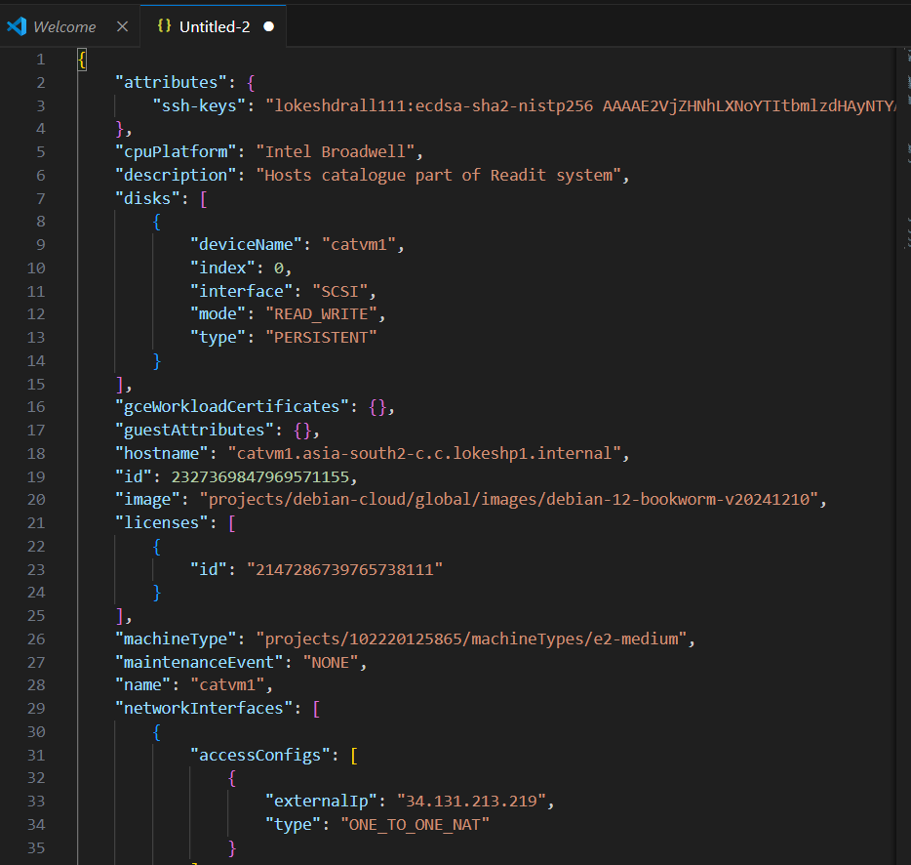

1. Now go back to the GCP console vm instance page, and open your instance, click edit

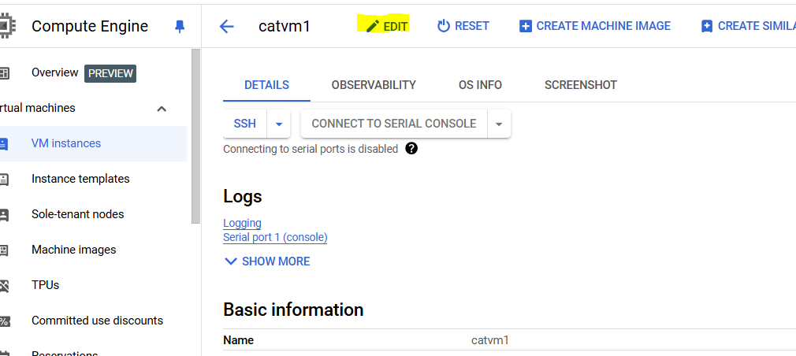

1. Scroll down to Metadata and click add item

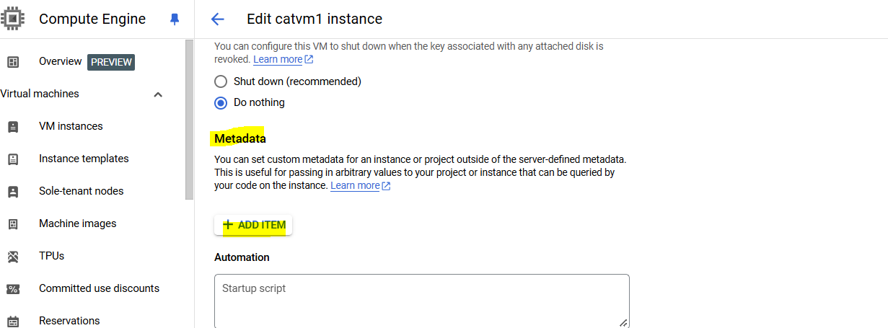

1. Add env as key and test as value, and click save

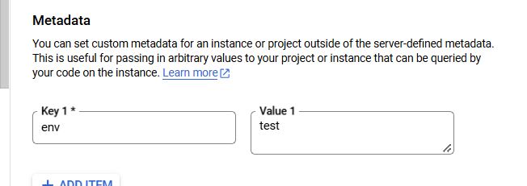

1. Now run previous command (repeat from step 8 till 14) and this time it will show the metadata which we added

